Use-Case Realization Report (Analysis)
View Workflow Queues

Issue <1.0>
Revision History
Date | Issue | Description | Author
<29/apr/11> | <1.0> | Initial Document | Koh Ming Jin

Table of Contents
1. Brief Description 4
2. Flow of Events 4
2.1 Standard Flow 4
2.2 Exception 4
3. Interaction Diagrams 4
3.1 Collaboration Diagram for View Workflow Queues 4
4. Participating Objects 5
4.1 View Workflow Queues Information Page 5
4.2 Workflow Controller 5
4.3 Workflow 5
4.4 Queue 5
4.5 Cylinder 5
5. Class Diagrams 5
5.1 Domain Class Diagram: View Workflow Queues 5
6. Derived Requirements 5

Use-Case Realization Report
View Workflow Queues

Brief Description
This use case enables an operation manager to view the queues for a particular workflow.

Flow of Events
The standard flow of events for this use case and any exceptions are described in the following subsections. See section 3.1 for an overview of the participating Actors and Domain Objects.

Standard Flow
The flow of events is described as follows:

- The use case starts when Operation Manager selects the View Workflow Queues option of the system.
- The View Workflow Queues Page, which includes all the Workflow Queues details, is displayed.
- The use case terminates.

Exception
- NIL

Interaction Diagrams

Collaboration Diagram for View Workflow Queues
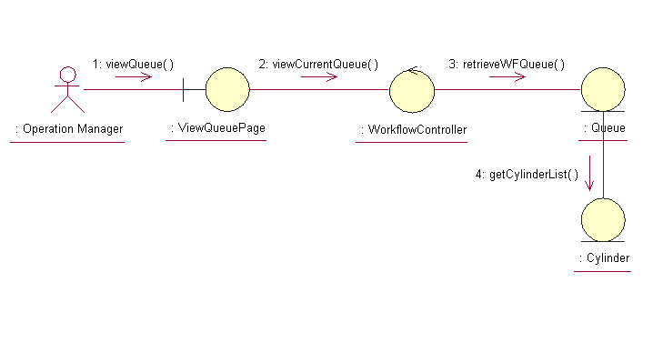

Participating Objects

View Workflow Queues Information Page
This object renders the contents to allow authorized actors to view the workflow queues information. The Director, Department Manager and Operation Manager actors use this object.

Workflow Controller
This object acts as the middleman between “View Workflow Queues information” Page and the Workflow object. It will translate interactions with the view into actions to be performed by the Workflow, Queue and Cylinder objects.

Workflow
This object stores the details concerning the workflow information of the COMS.

Queue
This object stores the details concerning the workflow queues information of the COMS.

Cylinder
This object stores the details concerning the cylinder information of the COMS.

Class Diagrams

Domain Class Diagram: View Workflow Queues
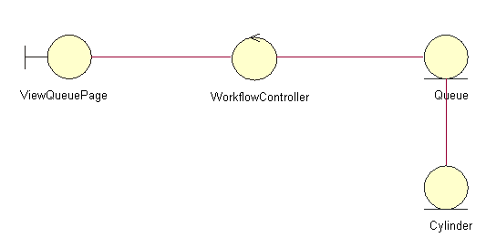

Derived Requirements
The Operation Manager PC keyboard and mouse will be used to retrieve Workflow Queues details (if any) and view all the system responses.

